Introduction:

The problem that was to be solved was to draw different shapes and sizes using python

Solution:

I first attempted at the problem by plugging in different values and seeing what shapes I could generate, I followed it up by alternating the code with some different methods, and calling the methods several times using recursion. It was a lot of trial and error, in the sense of plugging in and seeing the results. But at the end I managed to generate the figures.

Results:

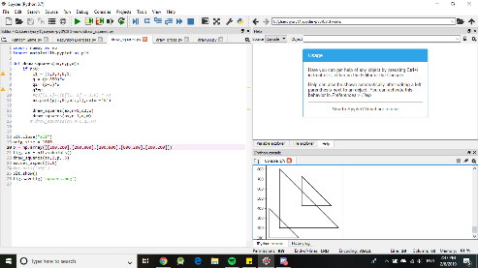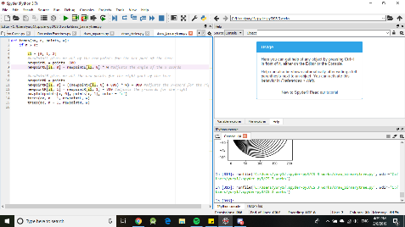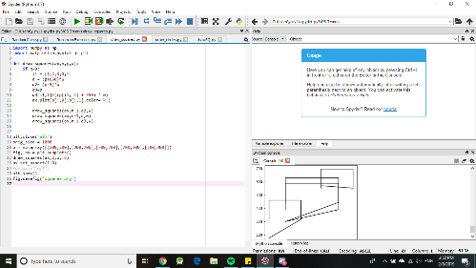The experiments included running the program several times, and finding out the outputs. The running times.

Conclusions:

I learned that some simple code can be turned into a shape.

I Yury Ionov certify that this project is entirely my own work. I wrote, debugged, and tested the code being presented, performed the experiments, and wrote the report. I also certify that I did not share my code or report or provided inappropriate assistance to any student in the class.